The Scandinavian Highschool of Design (Den Skandinaviske Designhøjskole

Brusgaardsvej 25, 8960 Randers, DK
56,4054611 and 10,1094862

How to get there by plane in combination with train/bus.

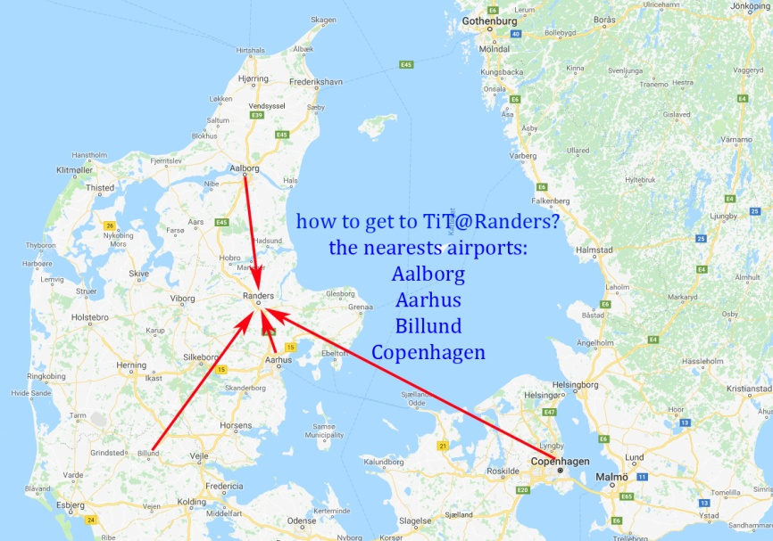

Catch a plane bound for Aalborg and take the bus (12, 70 or 200) which will take you to the railway station in Aalborg. Take a train towards Copenhagen, but make sure you get off in Randers after 1½ hours
You can also catch a plane bound for Billund Airport, from where you take a bus to Vejle – approx. half an hour, and in Vejle you catch a train going north to Randers, which takes 1½ hours
Finally you can also catch a plane bound for Copenhagen and there you take the train to Randers which takes about 4½-5 hours . Out of Copenhagen, there is also a low budget Flix bus service to Randers.
…
When you arrive in Randers, we will organize a private shuttle service, in which case we would like you to inform us in due time – 2 days, please – if you need that option.

